**Australian Islamic College 2020**

**ATAR Chemistry Units 3 and 4**

**Task 9 (Weighting: 5%)**

**Holiday Homework Validation Test**

**Proteins and Amino Acids**

Test Time: 40 minutes

Please do not turn this page until instructed to do so.

|  |  |
| --- | --- |
| **First Name** | **Surname** |
| **ANSWERS** |  |

|  |
| --- |
| **Teacher** |
|  |

|  |  |
| --- | --- |
| **Mark / 32** | **Percentage** |
|  |  |

Equipment allowed: Pens, pencils, erasers, whiteout, correction tape, rulers and non-programmable calculators permitted by the Schools Curriculum and Standards Authority.

**Special conditions**:

2 marks will be deducted for failing to write your full name on this test paper.

**Teacher help**: Your teacher can only help you during your test in one situation.

If you believe there is a mistake in a question show your teacher and your teacher will tell you if there is a mistake in the question and if appropriate, how to fix that mistake.

**Spelling of Science words** must be correct. Unless otherwise indicated, science words with more than one letter wrong (wrong letter and/or wrong place) will be marked wrong. The spelling of IUPAC names must be exactly correct.

Unless otherwise stated, **equations** must be written balanced and with correct state symbols or they will be marked wrong.

Questions must be answered in this booklet.

Total marks: 32

**Part A: Multiple Choice Section (7 Marks)**

1. At the molecular level, a protein called Protein P is shaped like a coil. When a solution of Protein P is mixed with citric acid, solid lumps form. The change in the structure of Protein P is due to
   1. Hydrolysis.
   2. **Denaturation.**
   3. Polymerisation.
   4. The formation of peptide bonds.
2. Which one of the following is a dipeptide made from α-amino acids?

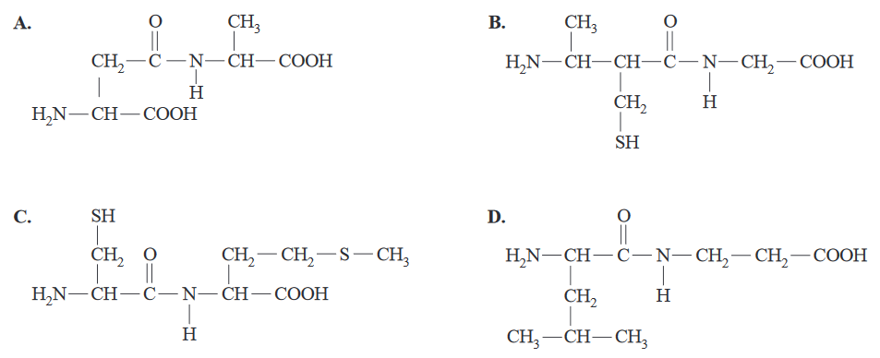

**The answer is C.**

1. Which one of the following is a correct statement about the denaturation of a protein?
   1. Denaturation is characterised by the release of amino acids.
   2. **Alcohol denatures proteins by disrupting the hydrogen bonding.**
   3. Denaturation involves disruption of peptide bonds.
   4. The primary and secondary structures are disrupted when denaturation occurs.
2. Substance P is a peptide found in the human body and it is associated with inflammation and pain. The structure of Substance P is shown below.

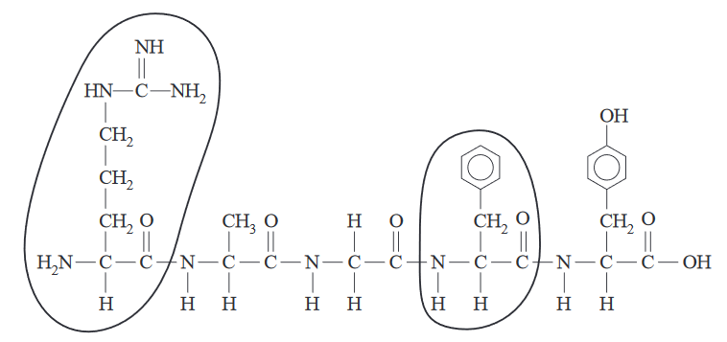

What are the abbreviated names of the two circled amino acid residues?

* 1. **Arg and Phe**
  2. Lys and Tyr
  3. Phe and Tyr
  4. Met and Arg

1. Met-enkephalin (Tyr–Gly–Gly–Phe-Met) is a peptide found in the central nervous system and the gastrointestinal tract of the human body. Which of the following are the correct structures for the two terminal ends of met-enkephalin at a very low pH?

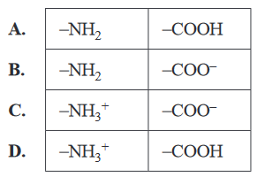

**The answer is D.**

1. Australian jellyfish venom is a mixture of proteins for which there is no antivenom. Jellyfish stings are painful, can leave scars and, in some circumstances, can cause death. Some commercially available remedies disrupt ionic interactions between the side chains on amino acid residues. These products most likely disrupt the protein’s
   1. Primary structure only.
   2. Secondary structure only.
   3. **Tertiary structure only.**
   4. Primary, secondary and tertiary structures
2. Consider the following statements about the structure of proteins.

I The primary structure of a protein is determined by the sequence of amino acid residues.

II The secondary structure of a protein is the result of hydrogen bonding between –NH and –CO groups.

III The tertiary structure of a protein involves bonding between the side chains on the amino acid residues.

Of these statements

* 1. Only I and III are true.
  2. Only I and II are true.
  3. Only II and III are true.
  4. **I, II and III are all true.**

**Part B: Short Answer Section (25 Marks)**

1. A commercial chocolate spread is commonly used in sandwiches and desserts. This food contains high amounts of proteins, triglycerides and sucrose. Proteins are an important part of food. Proteins are broken down into smaller molecules during digestion.
   1. Proteins can be hydrolysed to produce alpha (α-) amino acids. Identify the structural feature/s common to all alpha (α-) amino acids.

(3 marks)

**A carboxyl group (1)**

**And an amine/amino group (1)**

**Bonded to the same carbon atom (1)**

* 1. Two of the amino acids in the chocolate spread are cysteine and aspartic acid. Draw the chemical structure of the dipeptide Cys-Asp at high pH.

(4 marks)

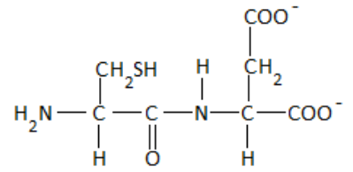

**NH2 correct (1)**

**Each COO- correct (1 each = 2)**

**All other atoms (1)**

1. Draw the zwitterion of proline.

(2 marks)

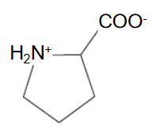

**1 mark off per mistake.**

1. Glucagon is a peptide hormone that works with insulin to help regulate blood glucose levels. Glucagon acts to increase blood glucose levels through targeted action on the polysaccharide stored in the liver. Glucagon consists of a chain of 29 amino acids, the sequence of which is given below, and folds to form a short alpha-helix.



* 1. Draw a diagram of the structure of the section of the glucagon peptide shown in the box in the amino acid sequence above.

(3 marks)

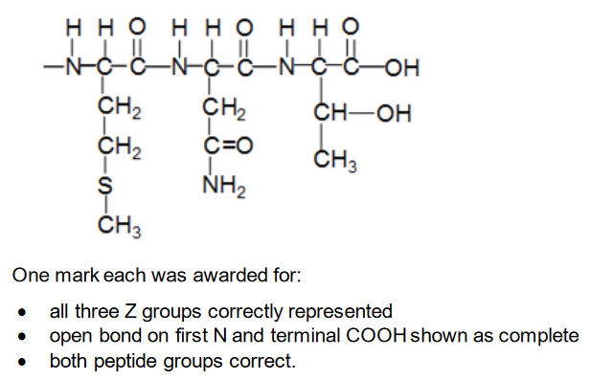

* 1. Describe the bonding that is found in the primary and secondary structures of the glucagon molecule.

(2 marks)

**Primary structure: Covalent bonds / peptide links (between C and N in the peptide links between amino acids) (1).**

**Secondary structure: Hydrogen bonds between O (– C=O) and H (–N–H) (on different peptide groups in the α-helix / β-sheet) (1).**

1. Amino acids can be classified according to the nature of their side chains (R groups). These may be polar, non-polar, acidic or basic.
   1. Referring to your data booklet, name one amino acid that has a non-polar side chain and one amino acid that has an acidic side chain. 2 marks•

Amino acid with a non-polar side chain:

(1 mark)

**Any one of:**

**Alanine/glycine/isoleucine/leucine/methionine/phenylalanine/proline/valine/Ala/Gly/Ile/Leu/Met/Phe/Pro/Val**

Amino acid with an acidic side chain:

(1 mark)

**Either one of:**

**Aspartic acid/glutamic acid/Asp/Glu**

* 1. The table below provides examples of different categories of side chains at a pH of 7.

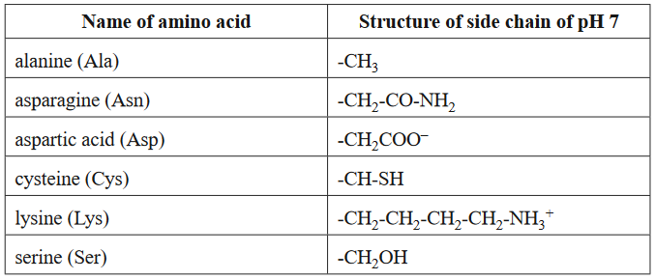

The tertiary structure of proteins is a result of the bonding interactions between side chains of amino acid residues. Use the information provided in the table above to

* + 1. Identify the amino acid that is involved in the formation of disulfide bonds (sulfur bridges)

(1 mark)

**Cysteine or Cys**

* + 1. Give an example of two amino acid side chains that may form hydrogen bonds between each other.

(1 mark)

**Asparagine and serine or Asn and Ser or**

**–CH2CONH2 and –CH2OH**

**No half marks.**

* + 1. Give an example of amino acid side chains that may form salt bridges between each other.

(1 mark)

**Aspartic acid and lysine or Asp and Lys or**

**–CH2COO– and –CH2CH2CH2CH2NH3+**

**No half marks.**

* + 1. Identify the type of bonding that exists between the side chains of two alanine residues.

(1 mark)

**Dispersion forces**

1. To consider the effect of having both an amine and a carboxylic acid functional group on the same molecule, amino acids can be compared with other organic compounds that have either:

● two amine functional groups on the same molecule (these compounds are called diamines) or

● two carboxylic acid functional groups on the same molecule (these compounds are called dicarboxylic acids).

Amino acids have significantly higher melting points than diamines and dicarboxylic acids of similar mass and structure. This is illustrated in the table below.

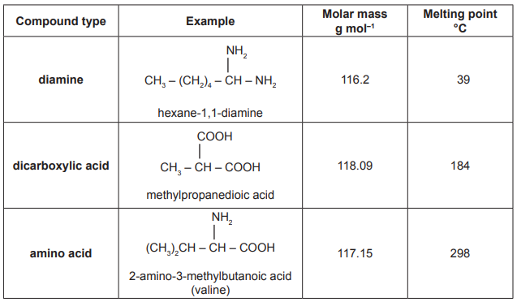

Explain why amino acids form crystalline solids and have significantly higher melting points than other organic molecules of similar mass and structure. Refer to the information provided in the table and include a labelled diagram using the amino acid valine to illustrate your answer.

(5 marks)

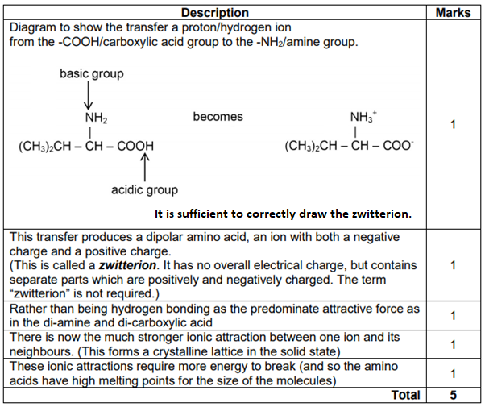

**End of Test**